1. Create user with name Techie and provide sudo access to user.

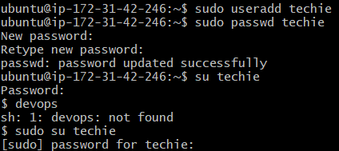

2. Navigate to the home directory.

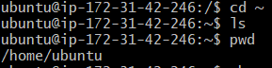

3. Create a new directory.

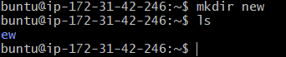  
4. List the contents of a directory.



5. Change the current directory.



6. Create a new empty file.

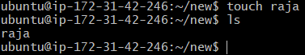

7. View the contents of a file.



8. Copy a file to another location.

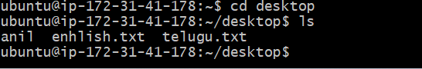

9. Move a file to another location.